UNICOI COUNTY PUBLIC LIBRARY
MINUTES OF THE BOARD OF TRUSTEES MEETING
April 30, 2026
The Board of Trustees of the Unicoi County Public Library met on April 30, 2026, at the Unicoi County Public Library in Erwin, TN. Members present at the meeting were President, Cathy Griffith, Vice President, Gail Snodgrass, Treasurer, Jan Bowden, and Terry Wise. Andy Frazier, secretary, Jenna Lafever, and Stana Donnelly. were absent.
Also present were UCPL Director Morgan Olson and Holston River Regional Library Director Jennifer Breuer.
- Call of meeting to order. Ms. Griffith called the meeting to order at 6:09 pm.

  - No public comments.
III. Approval of the March 2026 meeting minutes.
a. Upon the motion of Mr. Wise, seconded by Ms. Bowden, the minutes of March 2026 meeting were unanimously approved.
IV. Treasurer's report. Ms. Bowden shared the March financial statement.
- Discussion regarding the current finances. It was determined that the numbers in the financial statements will not be quoted in the meeting minutes in an effort to avoid mistakes in the record. The financial statements will be attached to the board packets and will stand alone for financial balance reporting.
- Approval of the March financial report. Upon the motion of Ms. Snodgrass, seconded by Mr. Wise, the financial report was approved unanimously.

V. Director's report. Ms. Olson reported that:
a. Program attendance is generally on the increase.
b. The summer reading program begins on June1st.
c. There will be a cookout June 3rd.
d. Collections re-barcoding is in process.
e. The AED and Narcan stations are going to be installed.
f. The TLC system is having issues. The library is working with TLC to resolve those issues. OWL is to oversee TLC. There is an effort to standardize for all libraries overseen by OWL.
g. A grant for the community garden irrigation system has been requested.
h. CSX no longer owns the building and parking adjacent to the library. The library will reach out to the new owner to request use of the parking lot during the Apple Festival for fundraising.

VI Holston River Regional Library Report. Ms. Breuer shared that:
- There is a trustee workshop on May 14th.
- A LAMP session for staff training is on May 28th.
- The new library in Gray is opening next month.
- UCPL Board member Terry Wise received his certification.

VII. President's Report. Ms. Griffth shared that :
- Each UCPL employee received a gift card from the Foundation Board.
VIII. Toney Foundation report. Ms. Griffith shared that:
- The Toney Board has its next meeting in May.
- Funding underway for new AED and First Aid kit as well as for new carpet.
- The Town of Erwin will be asked to assist with payment for new carpet.
IX. Unicoi County Public Library Foundation report. : See above
X. Old Business. None.
XI. New Business
- The new library insurance policy has been renewed and has increased in price. The insurance has been expanded to include coverage of owned and non-owned vehicles for staff conducting library business.
- The circulation policy was changed to include DVD check out duration of 14 days.
- New Board member appointment will come up in July. The recommendation for the new board position is Juan Villaba.
- Approval of the new policy and board appointment nominee. Upon the motion of Ms. Bowden, seconded by Mr. Wise, both were approved unanimously.
Xll. Board comments. None
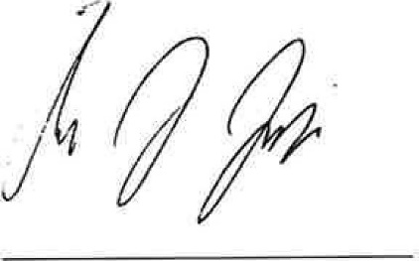
Xlll. Adjournment. Upon the motion of Ms. Snodgrass, seconded by Ms. Bowden, all agree to adjourn the meeting at 7:00. The next meeting will be Thursday, May 25, 2026, at 6:00pm at UCPL. Respectfully submitted,

Andy Frazier, Secretary

