UNICOI COUNTY PUBLIC LIBRARY
MINUTES OF THE BOARD OF TRUSTEES MEETING
January 22nd, 2026
The Board of Trustees of the Unicoi County Public Library met on September 25th, 2025, at the Unicoi County Public Library in Erwin, TN. Members present at the meeting were President, Cathy Griffith, Vice President, Gail Snodgrass, Treasurer, Jan Bowden, Terry Wise. Secretary, Andy Frazier, Stana Donnelly, and Jenna Lafever were absent.
Also present were UCPL Director Morgan Olson, Holston River Regional Library Regional Services Coordinator Lisa Livesay.
- Call of meeting to order. Ms. Griffith called the meeting to order at 6:00 pm.

  - Public comment. Mark Loewe presented an opportunity to the Library Boad for a railway camera to be installed on the library building. This would stream footage of the trains going by on the CSX line. This is part of a podcast called Steel Highway. There are over 92 host sites of train cameras, and it has over a million monthly viewers. Mr. Loewe stated that all the library would need to supply is power and internet and that it would lend exposure to Erwin and the library. This item will be referred to the Toney Board for a vote and to discuss CSX policy regarding filming.
III. Approval of the November 2026 meeting minutes.
a. Upon the motion of Mr. Wise, seconded by Ms. Snodgrass, the minutes of November 2026, meeting were unanimously approved.
IV. Treasurer's report. Ms. Bowden shared the November and December financial statement
a. Approval of the November and December 2025 financial report. Upon the motion of Mr. Wise, seconded by Ms. Bowden, the financial report was approved unanimously

V. Director's report. Ms. Olson reported that:
a. The Gingerbread and Santa event hosted 45 visitors this year.
b. The Shop Small event netted $520.00 in sales.
c. Ms. Olson is running the teen’s programming while Casey is on maternity leave. The crochet program has expanded and is well attended.
d. BWXT STEM club is in talks with the library to start a program for teens.
e. The Mad Hatter Tea Party this year is set for February 13, and Food City is donating the food.
f. The Toney Foundation has provided the library with an AED device. The library staff will be trained on the device before it is installed.
g. The Toney Foundation has provided security cameras for the Library.

VI Holston River Regional Library Report. Ms. Livesay shared some updates from the regional library about upcoming training opportunities. There will be training opportunities using AI software, Facilities Management, and Accessibility Services.
VII. President's Report. :
- In regard to the Budget for next fiscal year, the Ms. Griffith spoke with the Comptroller for the Town of Erwin regarding future support of the library.
It was noted in this conversation that the yearly contribution will need to increase to allow the library to function at its current capacity.
VIII. Toney Foundation report. Ms. Griffith shared that:
- The Toney and UCPL Foundations are now both tax exempt. The proper paperwork has been filed for charitable purposes.
IX. Unicoi County Public Library Foundation report. : See above
X. Old Business. None.
XI. New Business
- There will be a training closure for the library for a half day February 0 for AED device training. Upon the motion of Ms. Snodgrass, seconded by Ms. Bowden, the motion to approve passed unanimously.
- In regard to the Collection Report to TN Secretary of State’s Office, the report was shared with the board. One change was made to the statement to add the word ‘laws’ to the document. Upon the motion of Mr. Wise, seconded by Ms. Boden, the motion to approve was carried unanimously.

Xll. Board comments. None
Xlll. Adjournment. Upon the motion of Ms. Boden, seconded by Mr. Wise, all agree to adjourn the meeting at 7:00. The next meeting will be Thursday, February 19, 2026 at 6:00pm at UCPL. Respectfully submitted,
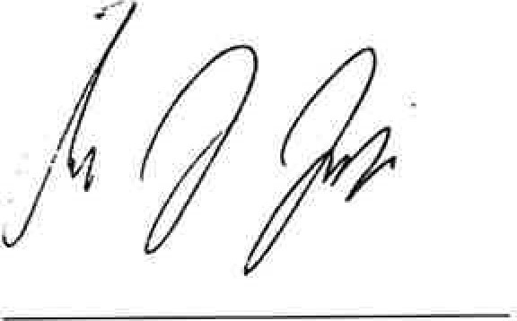
Andy Frazier, Secretary

